Are you interested in joining a new Twelve Step group in uptown Manhattan? We are Inwood ACA
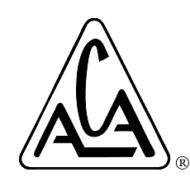
ACA stands for Adult Children of Alcoholics and Dysfunctional Families.
“The term ‘adult child’ is used to describe adults who grew up in alcoholic or dysfunctional homes and who exhibit identifiable traits that reveal past abuse or neglect…Ours is one of the few Twelve Step fellowships that embraces the difficult task of trauma work, which can often lead to an exciting journey to the Inner Child or True Self.” – Excerpted from, and learn more at, www.adultchildren.org

It starts February 7 and will be on Tuesdays, 7:30pm-8:45pm* at
Holy Trinity Episcopal Church, 20 Cumming Street, NY NY 10034
(near 200th St and Broadway, around the corner from the Dyckman St A Train Stop)
*Coming late and/or leaving early are completely fine with us!
For more information, or to help out, please contact Gaby K. at 217-220-1339 and/or gpkogut@gmail.com. (Indicate that Inwood ACA is your subject.)
Please sign up if you are interested in attending this group at least twice a month.
Name (first and last initial) Email Address Phone Number
1.
2.
3.
4.
5.
6.
7.
8.
9.
10.
11.
12.
13.
14.
15.
16.
17.
18.
19.
20.
21.
22.
23.
24.
25.
26.
27.
28.
29.
30.
31.
32.
33.
34.
35.
36.
37.
38.
39.

